import numpy as np
import pandas as pd
import matplotlib.pyplot as plt
import seaborn as sns
from sklearn.preprocessing import StandardScaler
from sklearn.decomposition import PCA

url = "https://raw.github.com/neurospin/pystatsml/master/datasets/iris.csv"
try:
df = pd.read_csv(url)
if df.shape[1] == 1 and df.columns[0].str.contains("version").any():
raise ValueError("LFS pointer file")
except Exception:
df = sns.load_dataset("iris")

df.columns = df.columns.str.strip().str.lower()
if "species" not in df.columns:
df = df.rename(columns={df.columns[-1]: "species"})

features = ["sepal_length", "sepal_width", "petal_length", "petal_width"]
X = df[features].astype(float)
y = df["species"]

means = X.mean()
stds = X.std(ddof=0)
print("Means and STDs before standardization:\n", pd.DataFrame({"mean": means, "std": stds}))
print("\nCorrelation matrix:\n", X.corr())

plt.figure(figsize=(6,5))
sns.heatmap(X.corr(), annot=True, fmt=".2f", cmap="vlag")
plt.tight_layout()
plt.show()

X_std = StandardScaler().fit_transform(X)
pca = PCA(n_components=X_std.shape[1])
scores = pca.fit_transform(X_std)
explained = pca.explained_variance_ratio_
cum_explained = np.cumsum(explained)

print("\nExplained variance ratio:")
print(explained)
print("\nCumulative explained variance:")
print(cum_explained)

n_components_needed = np.argmax(cum_explained >= 0.95) + 1 if np.any(cum_explained >= 0.95) else len(cum_explained)
print(f"\nComponents to reach 95% variance: {n_components_needed}")

comp_df = pd.DataFrame(pca.components_, columns=features, index=[f"PC{i}" for i in range(1, len(features)+1)])
print("\nPrincipal component directions:\n", comp_df)

combined = np.corrcoef(X_std.T, scores.T)
corr_vars_pcs = combined[:len(features), len(features):]
corr_vars_pcs_df = pd.DataFrame(corr_vars_pcs, index=features, columns=[f"PC{i}" for i in range(1, len(features)+1)])
print("\nCorrelations between variables and PCs:\n", corr_vars_pcs_df)

plt.figure(figsize=(6,4))
plt.bar(range(1, len(explained)+1), explained, alpha=0.6, align='center', label='Individual variance')
plt.step(range(1, len(cum_explained)+1), cum_explained, where='mid', label='Cumulative variance')
plt.xlabel('Principal Components')
plt.ylabel('Explained variance ratio')
plt.legend(loc='best')
plt.tight_layout()
plt.show()

plt.figure(figsize=(7,6))
sns.scatterplot(x=scores[:,0], y=scores[:,1], hue=y, palette="deep", s=60)
plt.xlabel("PC1")
plt.ylabel("PC2")
plt.title("Iris data projected on first two PCs")
plt.tight_layout()
plt.show()

OUTPUT:
Means and STDs before standardization:
mean std
sepal_length 5.843333 0.825301
sepal_width 3.057333 0.434411
petal_length 3.758000 1.759404
petal_width 1.199333 0.759693

Correlation matrix:
sepal_length sepal_width petal_length petal_width
sepal_length 1.000000 -0.117570 0.871754 0.817941
sepal_width -0.117570 1.000000 -0.428440 -0.366126
petal_length 0.871754 -0.428440 1.000000 0.962865
petal_width 0.817941 -0.366126 0.962865 1.000000
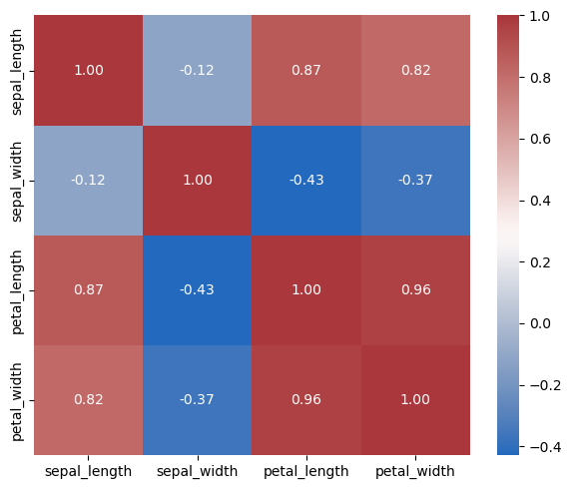

Explained variance ratio:
[0.72962445 0.22850762 0.03668922 0.00517871]

Cumulative explained variance:
[0.72962445 0.95813207 0.99482129 1. ]

Components to reach 95% variance: 2

Principal component directions:
sepal_length sepal_width petal_length petal_width
PC1 0.521066 -0.269347 0.580413 0.564857
PC2 0.377418 0.923296 0.024492 0.066942
PC3 0.719566 -0.244382 -0.142126 -0.634273
PC4 -0.261286 0.123510 0.801449 -0.523597

Correlations between variables and PCs:
PC1 PC2 PC3 PC4
sepal_length 0.890169 0.360830 0.275658 -0.037606
sepal_width -0.460143 0.882716 -0.093620 0.017776
petal_length 0.991555 0.023415 -0.054447 0.115350
petal_width 0.964979 0.064000 -0.242983 -0.075360
